LABORATORY EXERCISE 2

ENHANCING HTML STRUCTURE & CSS CREATIVITY WITH COLOR SCHEMES

Learning Objectives
By the end of this laboratory exercise, students should be able to:
- Enhance basic HTML structure by adding semantic elements (header, nav, main, section, footer)
- Apply CSS styling techniques including colors, fonts, spacing, and layout
- Select and implement a cohesive color scheme for a webpage
- Create a multi-section webpage with proper content organization
- Apply CSS box model concepts (padding, margin, border) effectively
- Use CSS flexbox for basic layout arrangements.

Prerequisite student experiences and knowledge
Before starting this exercise, students should have:
- Completed Laboratory Exercise 1
- Basic understanding of HTML tags (html, head, body, h1-h6, p, div, img)
- Familiarity with opening files via localhost and Live Server
- XAMPP and VS Code properly installed and configured.

Background
In Laboratory Exercise 1, you created your first HTML page, a simple document with basic structure and content. While functional, that page lacked visual appeal and proper content organization.
In real-world web development, websites are not just about presenting information; they need to be visually engaging, well-organized, and easy to navigate. This is where CSS (Cascading Style Sheets) becomes essential. CSS controls the presentation layer of your website, including colors, fonts, spacing, and layout.
A critical aspect of web design is the color scheme: a deliberate selection of colors that work harmoniously together. A well-chosen color scheme:
Creates visual hierarchy and guides user attention. Establishes brand identity and emotional tone. Improves readability and user experience. Makes your website look professional and polished
In this exercise, you will transform your basic HTML page into a visually appealing, well-structured webpage by adding semantic HTML elements and applying a carefully selected color scheme through CSS.

Materials/Resources
- Personal Computer with Internet Access (Windows, macOS, or Linux).
- XAMPP Installer (downloaded from apachefriends.org).
- Visual Studio Code (downloaded from code.visualstudio.com).
- Web Browser (Google Chrome is recommended).
- Github (https://github.com/)
- Color Scheme Resources (for reference):
  - Coolors.co Color palette generator
  - Adobe Color Color wheel and theme creator
  - ColorHunt Curated color palettes
Submission Guidelines
- Name the file as: Lab2_[YourStudentID]_[YourLastName].pdf (e.g., Lab2_20251234_Cruz.pdf).
- Submit the File to your instructor via the Learning Management System (LMS) provided before the start of the next laboratory session.

QUESTIONS:
- Explain the purpose and benefits of using semantic HTML elements (like <header>, <nav>, <main>, <section>, <footer>) instead of generic <div> elements. How do they improve web development?
Semantic HTML elements help organize a webpage. For example, <header> is for the top part, <nav> is for links, <main> is for the main content, <section> is for different parts, and <footer> is for the bottom part. They make the code easier to read and understand.
- Describe the color scheme you selected for your webpage. What type of color harmony did you use (monochromatic, complementary, analogous, or triadic)? List your colors with their hex codes and explain why you chose this particular scheme.
I used an analogous color scheme. My colors are Blue (#2563EB), Light Blue (#3B82F6), Sky Blue (#60A5FA), and Very Light Gray (#F8FAFC). I chose these colors because they look good together and make my webpage clean and simple.
- What is the CSS box model? Explain the difference between margin, padding, and border, and provide an example of how you used each in your CSS code.
The CSS box model has content, padding, border, and margin. Padding gives space inside an element. Border is the line around the element. Margin gives space outside the element. I used padding for inside spacing, border for an outline, and margin for space between elements.
- What is the difference between inline, internal, and external CSS? Why is external CSS (using a separate .css file) preferred for web development projects?
Inline CSS is written inside an HTML tag. Internal CSS is written inside the HTML file using <style>. External CSS is written in a separate .css file. External CSS is better because it keeps the code clean and makes it easier to edit the design.

- How does the hover pseudo-class work in CSS? Provide an example of a hover effect you implemented in your webpage and explain how it improves user experience.
The :hover pseudo-class changes the style of an element when the mouse is placed over it. I used hover effects on my navigation links. This makes the webpage more interactive and helps users know which link they are pointing at.
- Explain the difference between relative and absolute units in CSS. Give examples of when you would use each type.
Relative units depend on the size of another element or the screen. Examples are %, em, and rem. They are useful for responsive webpages. Absolute units have a fixed size, such as px. I can use pixels when I need a fixed size for an element.

Output / Result
Take a screenshot of the following outputs and paste them into your lab report document:
- Screenshot 1: VS Code editor showing your complete index.html code with semantic HTML structure
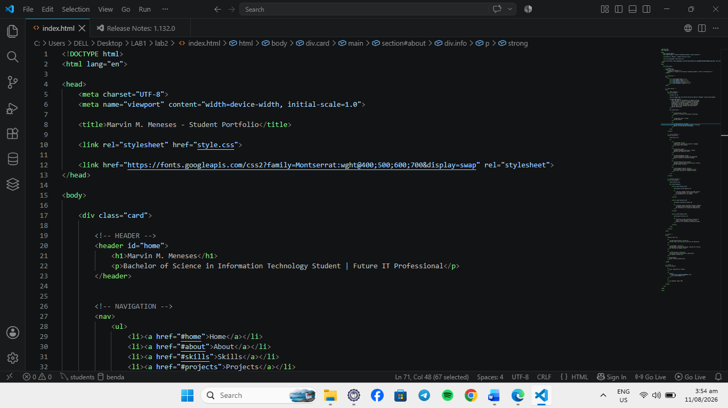

- Screenshot 2: VS Code editor showing your complete style.css code with your selected color scheme
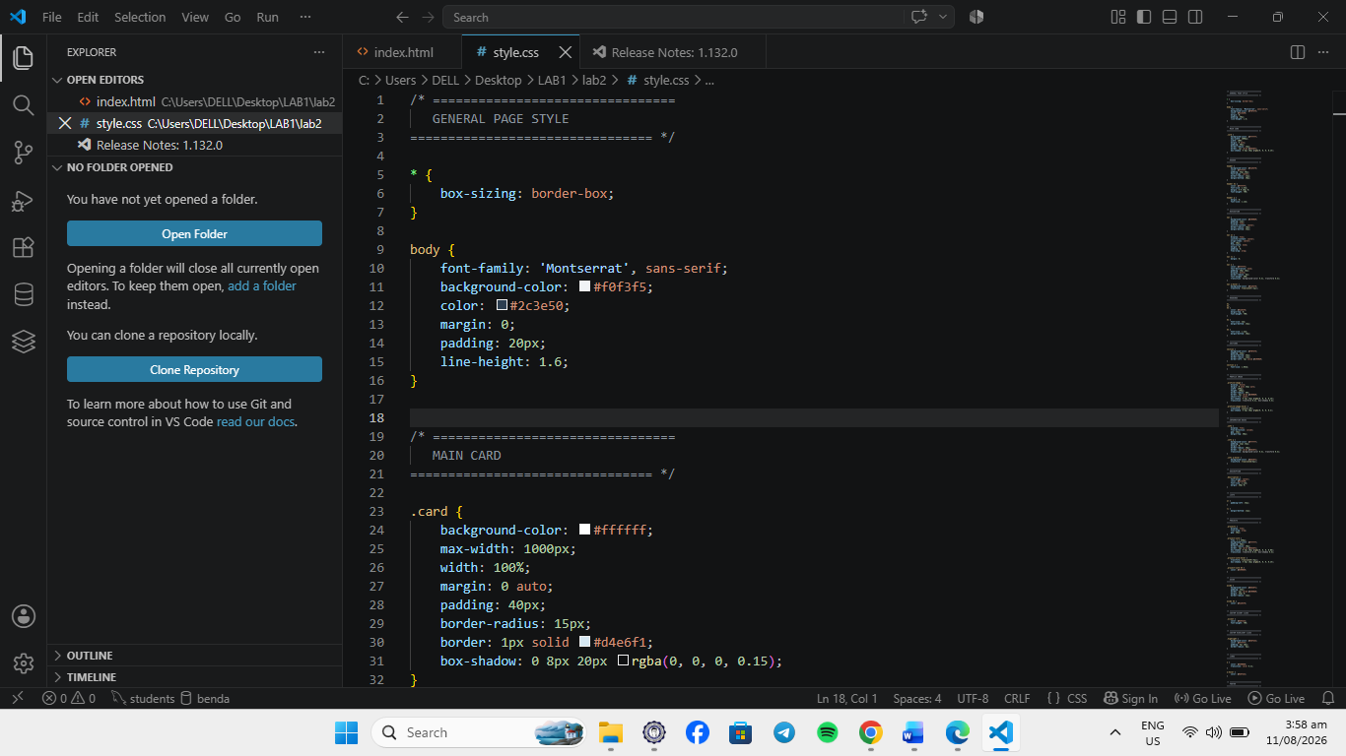
- Screenshot 3: Your web browser displaying the fully styled HTML page with the URL visible in the address bar (showing either http://localhost or http://127.0.0.1:5500)
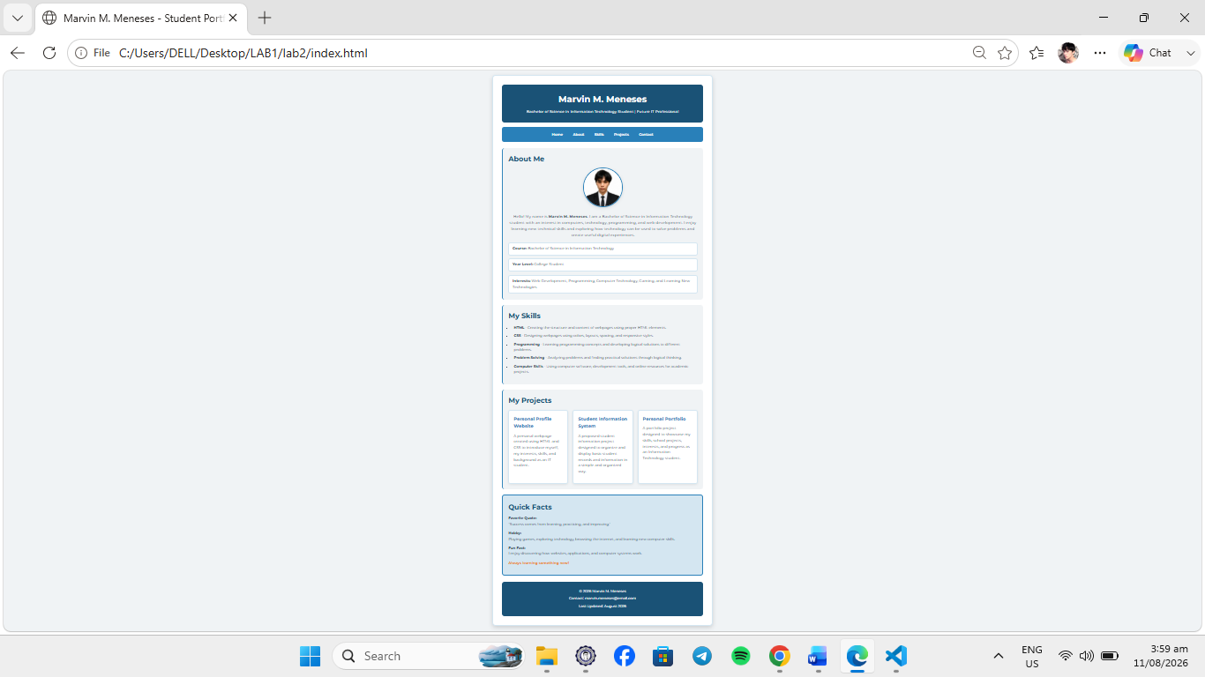
- Screenshot 4: Your GitHub repository showing the history of commits and the new lab2_YourStudentID folder
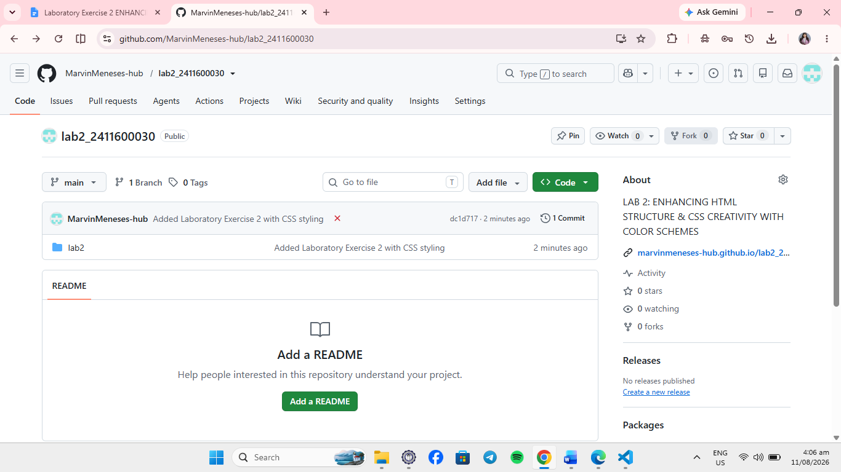
- Screenshot 5: A separate image or section showing the color palette/color scheme you selected (including hex codes)
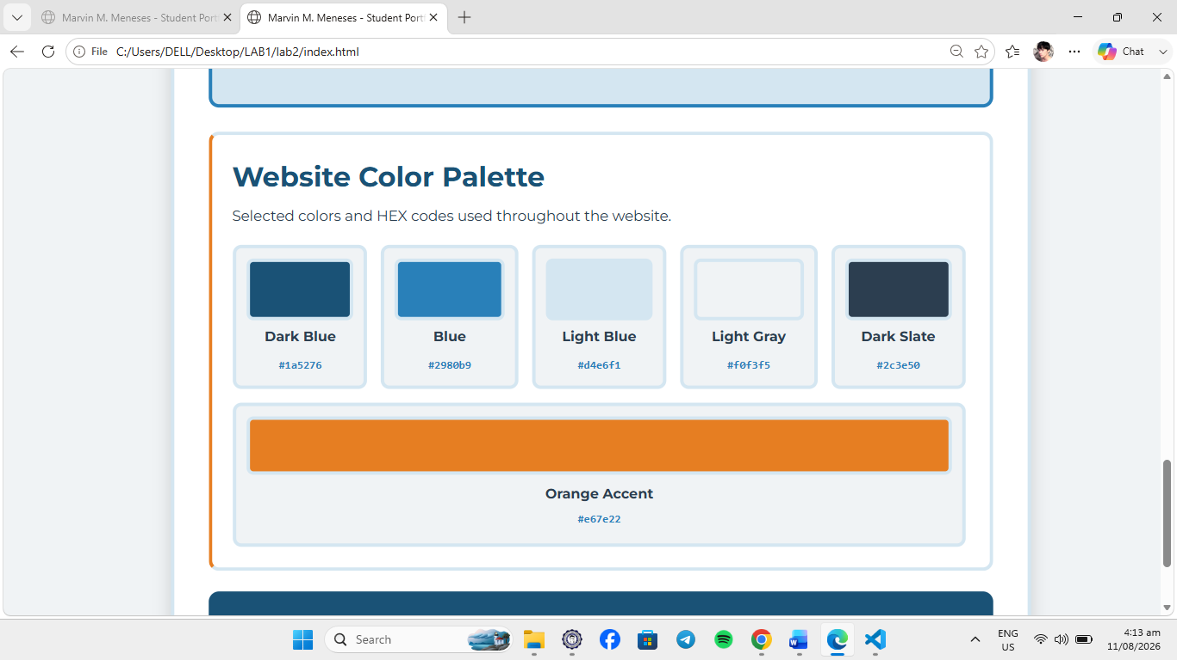
Conclusion
This laboratory exercise helped me learn how to improve an HTML webpage using CSS. I learned how to use semantic HTML, colors, spacing, borders, and hover effects. I also learned about different CSS units and the use of external CSS. Overall, this activity helped me create a cleaner and better-looking webpage. 🌸

